

**BRAC University**

**CSE 260 Project Fall 2022**

**Project Name:** Line Follower Robot

**Group No:** 08

**Group Members:**

* Ahtesham Ibne Mostafa, 21201342
* Maliha Binte Masud, 21201434
* Redwanur Rahman, 21301543
* Abdur Rahman Shafi, 21201442

**Theory Section:** 12

***Introduction:***

This project's goal was to create a line-following robot without the use of a microcontroller. The line-following robot was created to go along a predetermined course while adhering to a black line on a white surface.

***System:***

An L293D motor driver IC was used to build the line follower robot, together with IR proximity sensors to identify lines and a switch to turn the motors on and off. Battery-operated, the robot could travel a predetermined path by adhering to a white surface and a black line.

***Experimental Setup:***

The following components were used to build the line follower robot:

* L298D motor driver IC
* Jumper cables
* Motors and wheels
* Breadboard
* IR proximity sensors
* Switch to turn the motors on and off
* Batteries

The circuit diagram for the line follower robot is shown below:

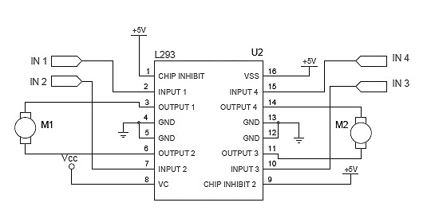

The IR proximity sensors are mounted on the front of the robot chassis and allow the robot to spin when a line is sensed. The L298N motor driver module receives a signal from the sensors when they detect the existence of a line, and it modifies the movement of the motors to steer the robot in the appropriate direction. The motors were switched on and off using the switch.

***Analysis:***

The IR proximity sensors are mounted on the front of the robot chassis and allow the robot to spin when a line is sensed. The L298N motor driver module receives a signal from the sensors when they detect the existence of a line, and it modifies the movement of the motors to steer the robot in the appropriate direction. The switch was used to turn on and off the motors. The results are summarized in the following truth table:

**For Motor 1:**

|  |  |  |
| --- | --- | --- |
| Pin 1 | Pin 2 | Motor 1 |
| 0 | 0 | X |
| 0 | 1 | X |
| 1 | 0 | 1 |
| 1 | 1 | 0 |

**For Motor 2:**

|  |  |  |
| --- | --- | --- |
| Pin 3 | Pin 4 | Motor 2 |
| 0 | 0 | X |
| 0 | 1 | X |
| 1 | 0 | 1 |
| 1 | 1 | 0 |

The VCC is connected to Pins 1 and 3 on the motor driver module in this instance. This indicates that because these pins are continually receiving electrical current, their values will never be 0. The truth table's first two min terms are marked as "Don't Cares" in this instance, indicating that the logical function's output is unaffected by the specific input value combinations in question. This is because, regardless of the input values of the other variables in the truth table, the values of Pin 1 and Pin 3, which are linked to VCC, will always be non-zero.

***Conclusion:***

Overall, the line-following robot was successful in following a black line on a white surface to go along a predetermined course. Since some of the wires we bought were faulty, we ran into some issues connecting the motor driver and sensors to the breadboard. The L298N motor driver module was able to correctly control the motors and steer the robot through the path once the wires were switched, allowing the IR proximity sensors to detect the existence of a line. The project did have certain constraints, though. For instance, the robot could only travel a straight route and could not negotiate complicated paths.